Experiment 13
Program:
import cv2
import numpy as np
# Read the image
img = cv2.imread("image.jpg")
# Get height and width
rows, cols, ch = img.shape
# Define 3 points in the original image
pts1 = np.float32([[50, 50], [200, 50], [50, 200]])
# Define their corresponding points in the output image
pts2 = np.float32([[10, 100], [200, 50], [100, 250]])
# Create the Affine Transformation matrix
matrix = cv2.getAffineTransform(pts1, pts2)
# Apply affine transformation
result = cv2.warpAffine(img, matrix, (cols, rows))
# Display images
cv2.imshow("Original Image", img)
cv2.imshow("Affine Transformed Image", result)
cv2.waitKey(0)
cv2.destroyAllWindows()
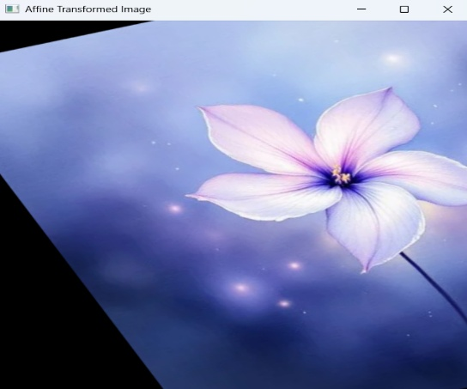
Output:

